Chapter 5 Tutorial Assignment - *Loops, Files and Random Numbers*

**Tutorial 5-1** pages 273 – 276

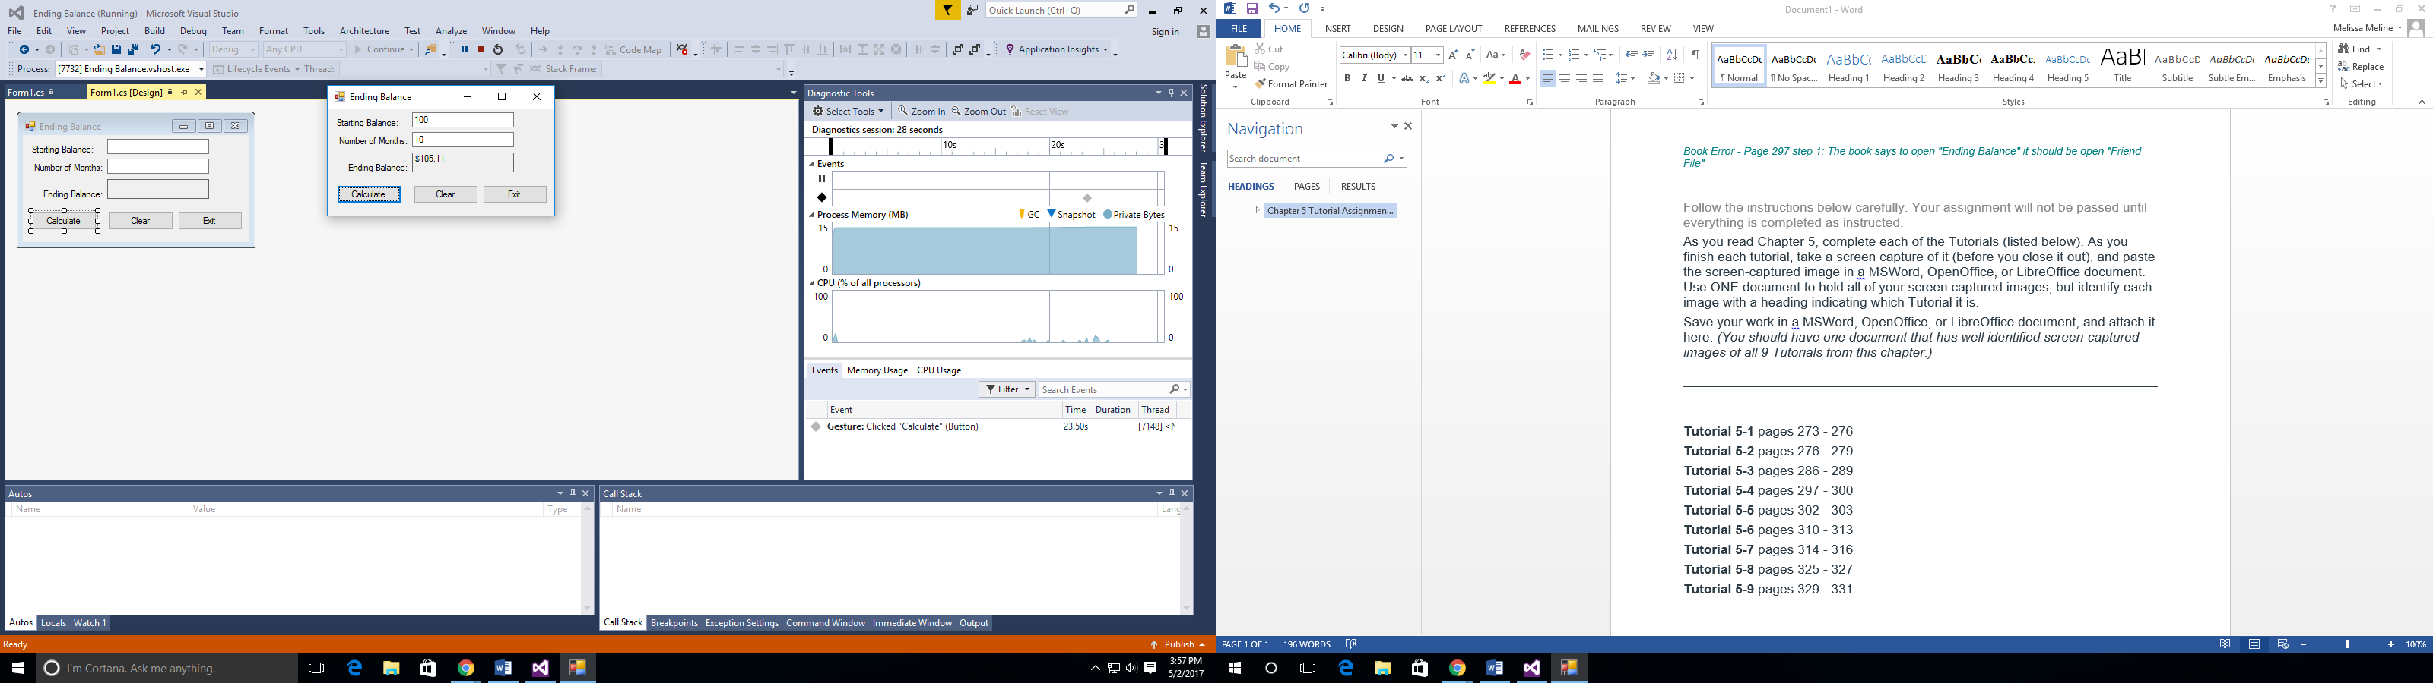

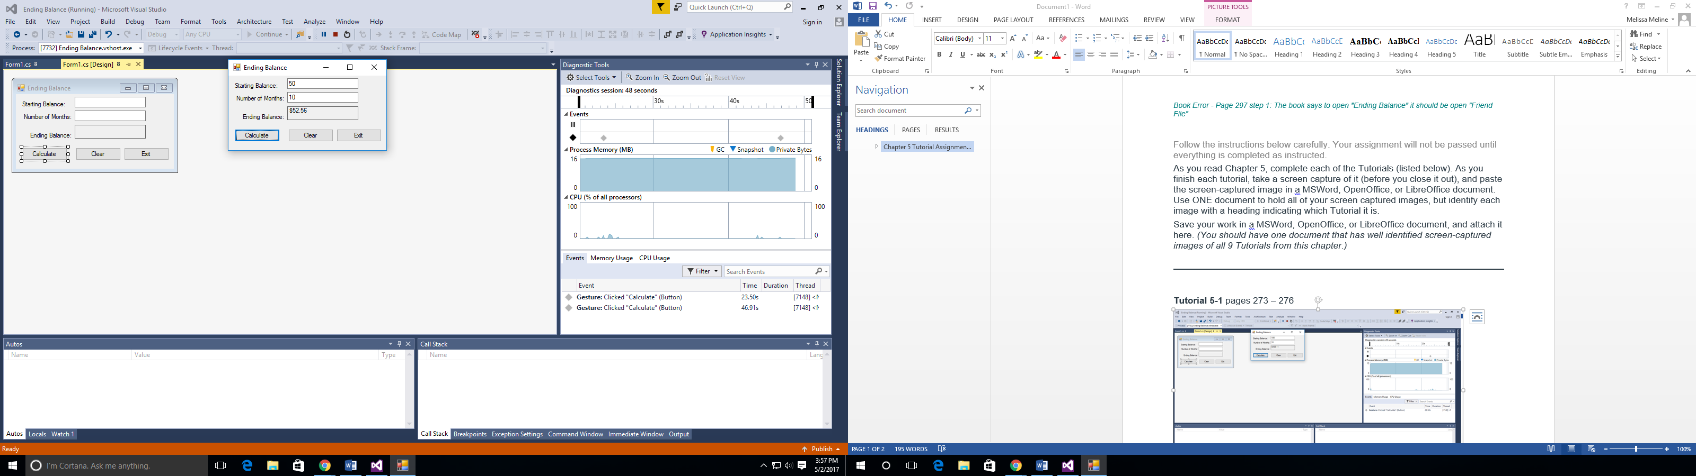

**Tutorial 5-2** pages 276 – 279

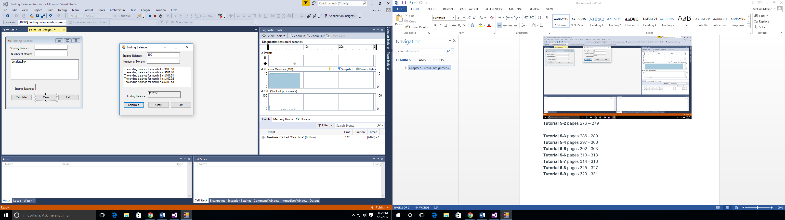

**Tutorial 5-3** pages 286 – 289

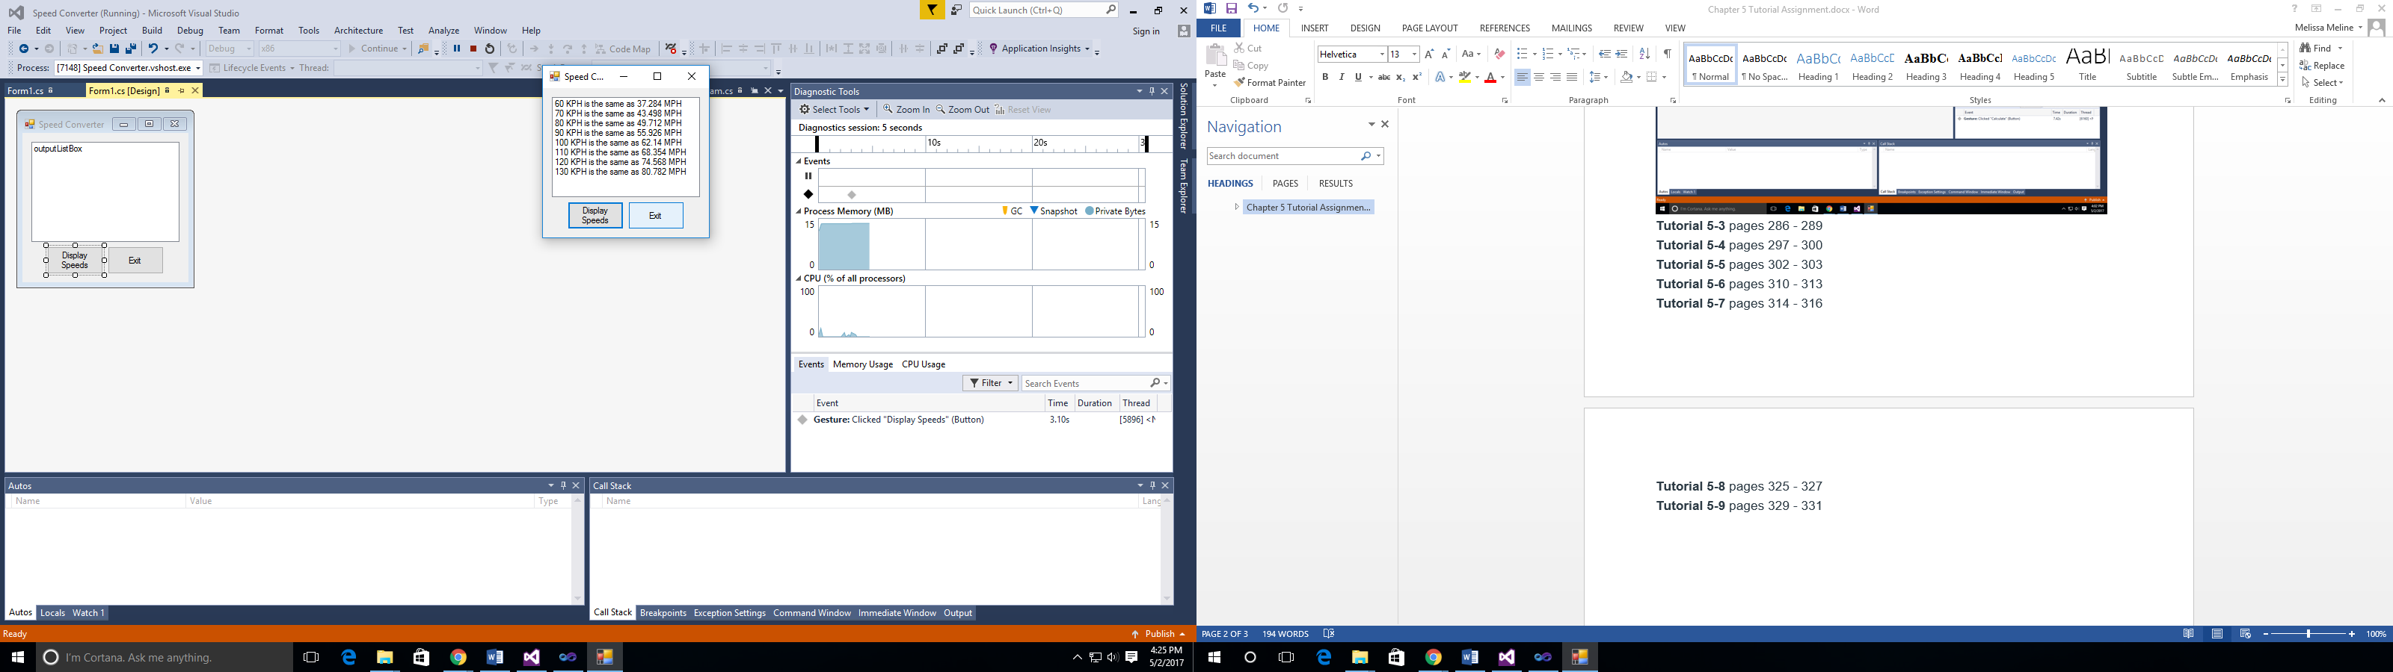

**Tutorial 5-4** pages 297 – 300

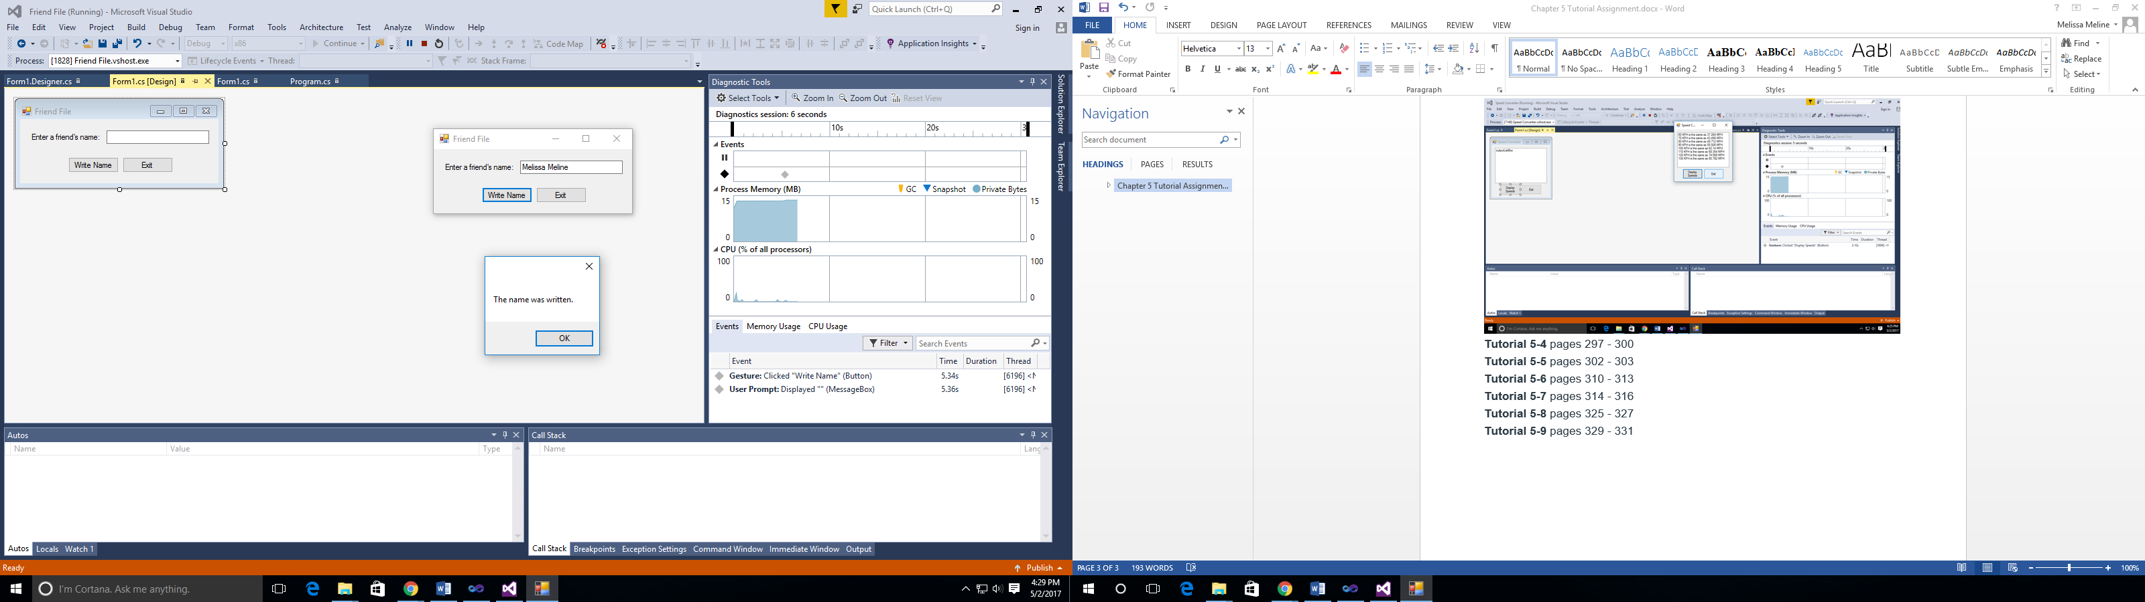

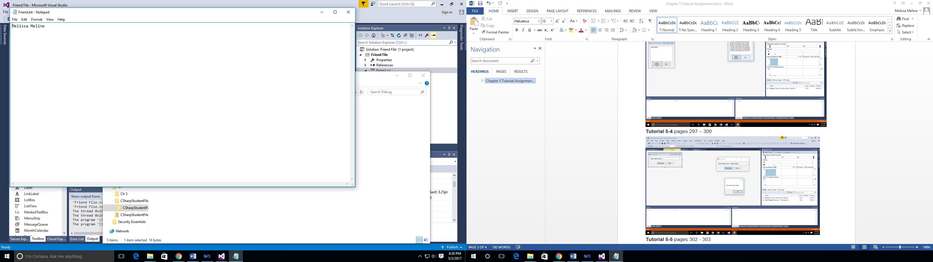

**Tutorial 5-5** pages 302 – 303

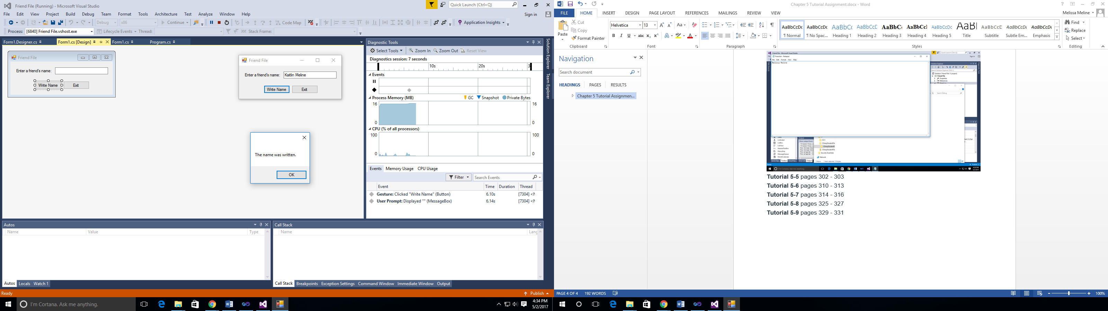

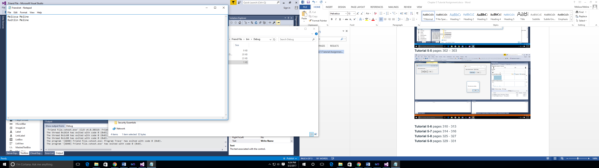

**Tutorial 5-6** pages 310 – 313

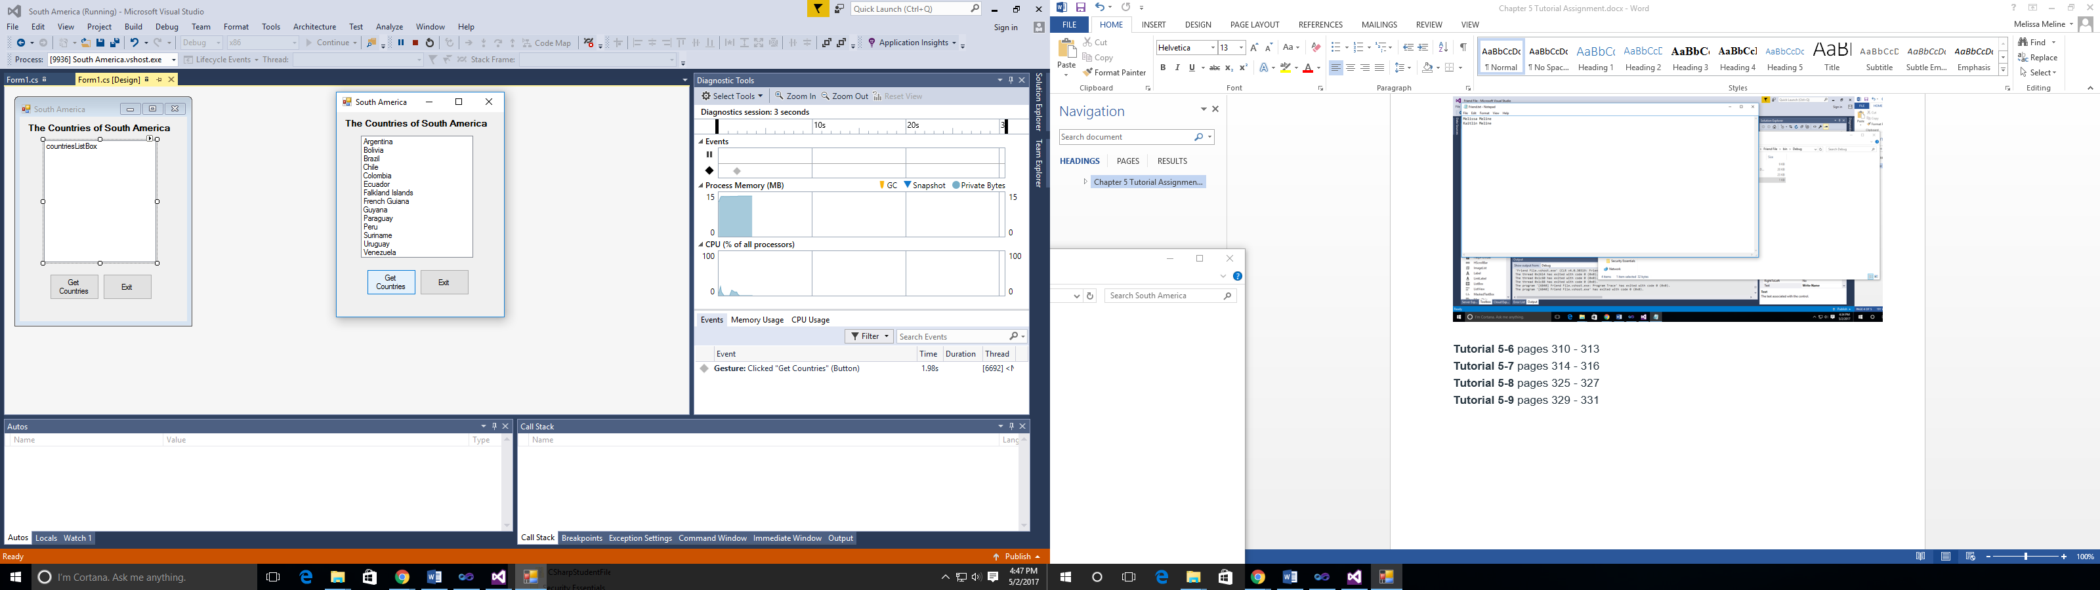

**Tutorial 5-7** pages 314 – 316

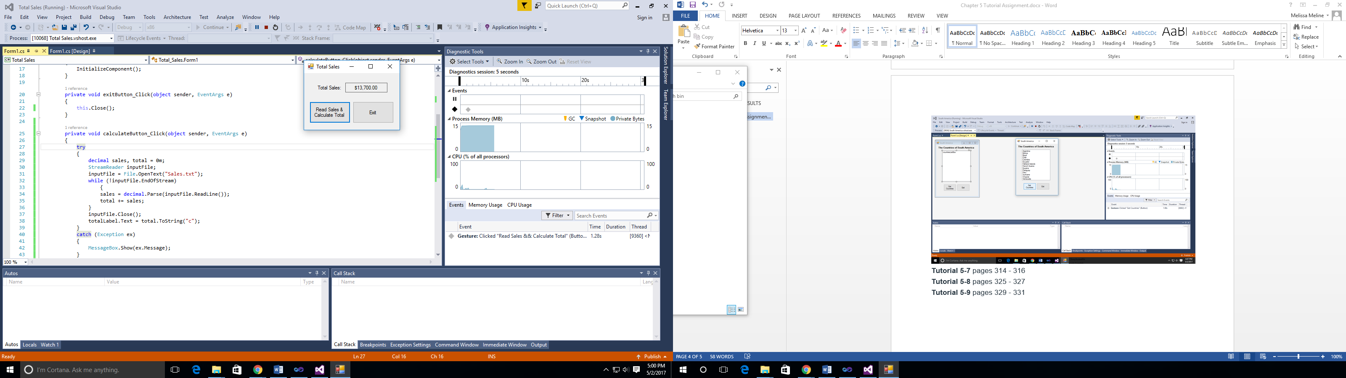

**Tutorial 5-8** pages 325 – 327

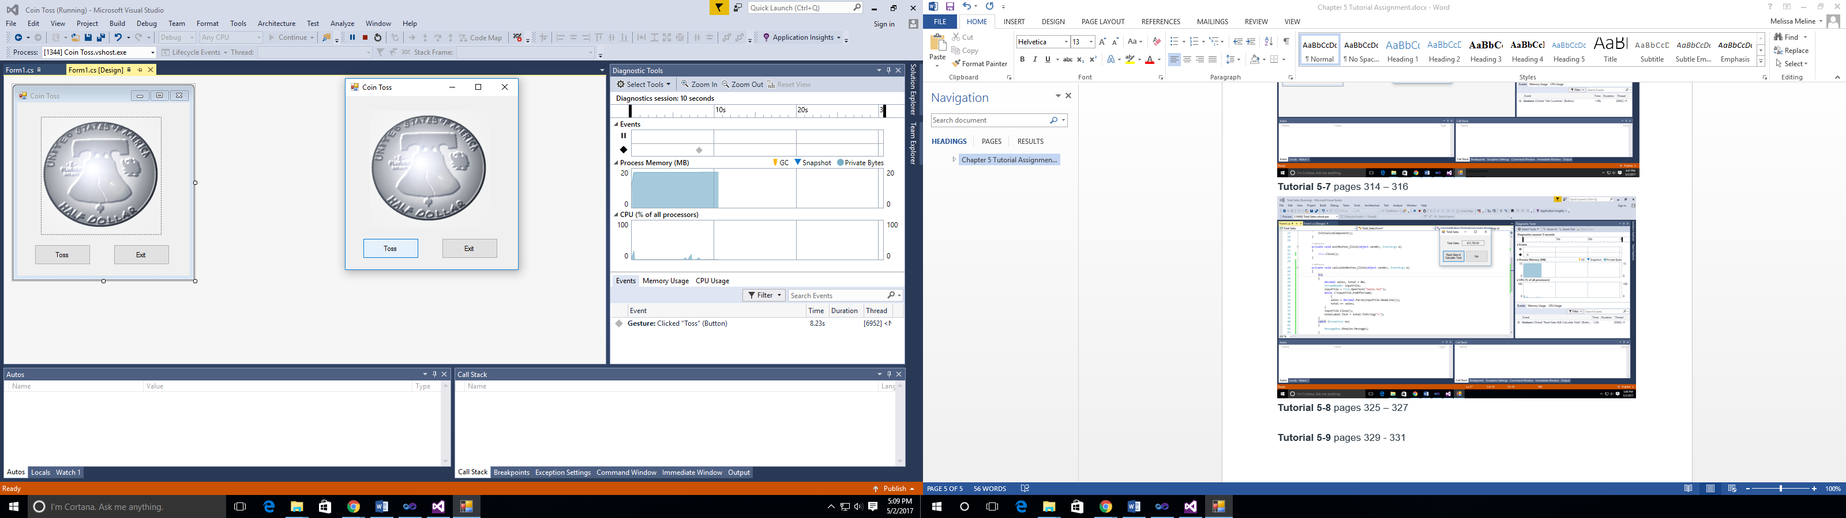

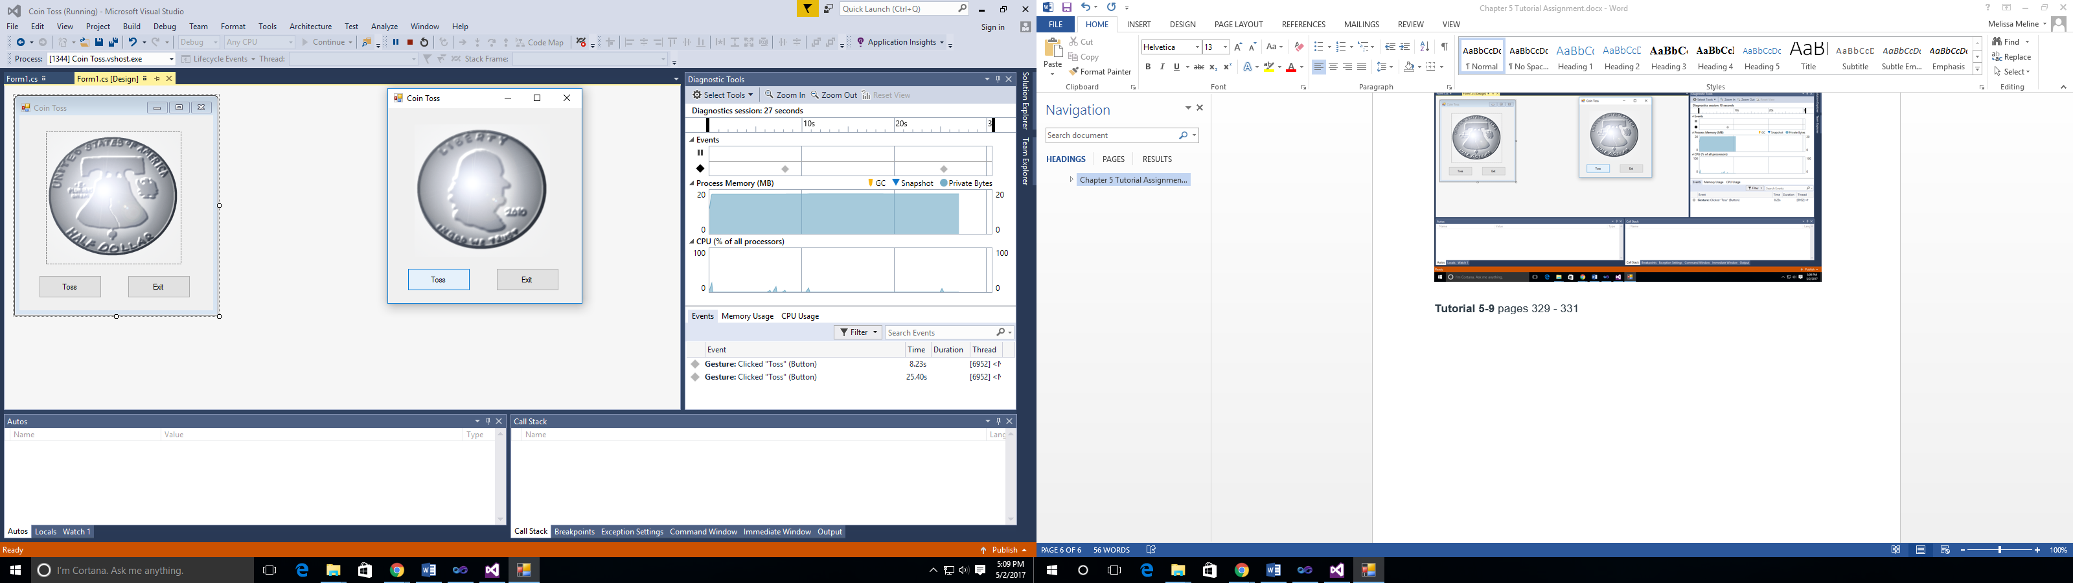

**Tutorial 5-9** pages 329 – 331

